**TABLE OF CONTENTS**

1. **SYSTEM ARCHITECTURE**
2. **UML DIAGRAMS**
   * 1. Use Case Diagram
     2. Sequence Diagram
     3. Class Diagram
     4. Component Diagram
     5. Deployment Diagram
3. **SYSTEM ARCHITECTURE**

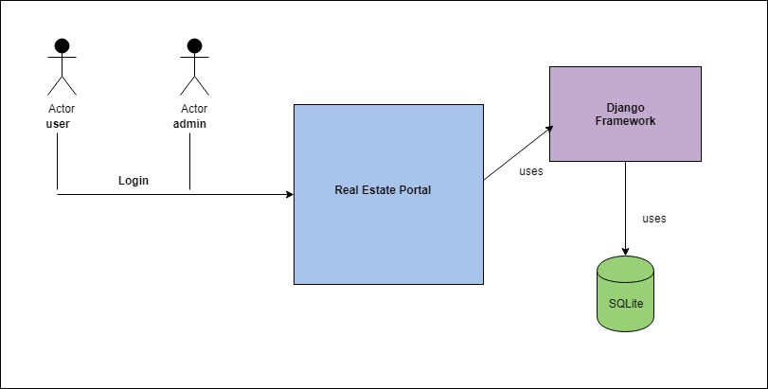

**2. UML DIAGRAMS**

1.1.1 Use Case Diagram

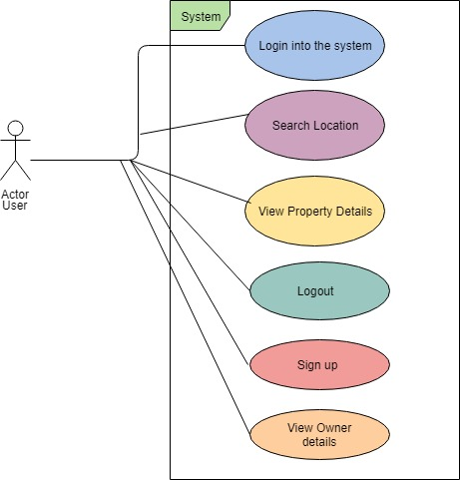

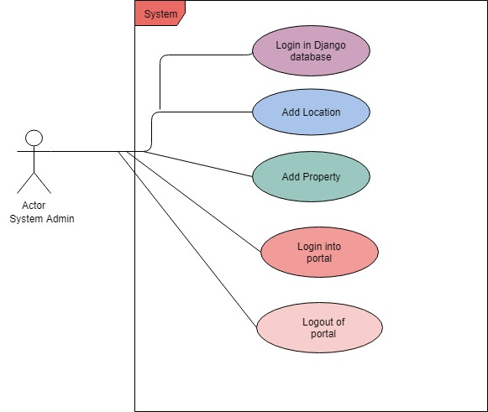

* + 1. Sequence Diagram

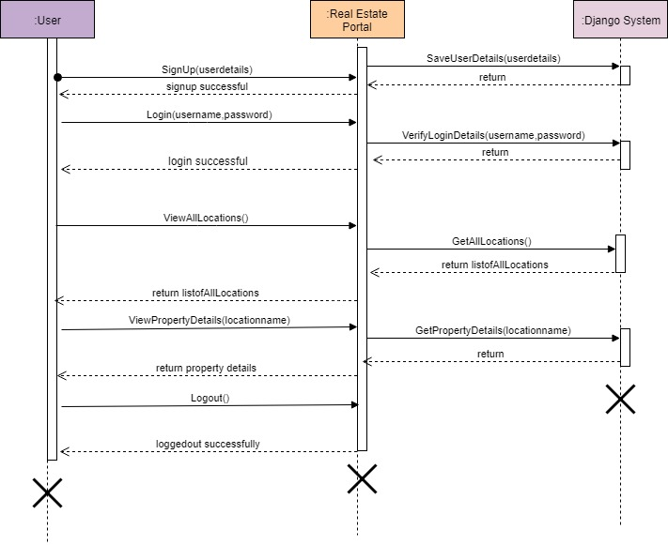

1.1.3 Class Diagram

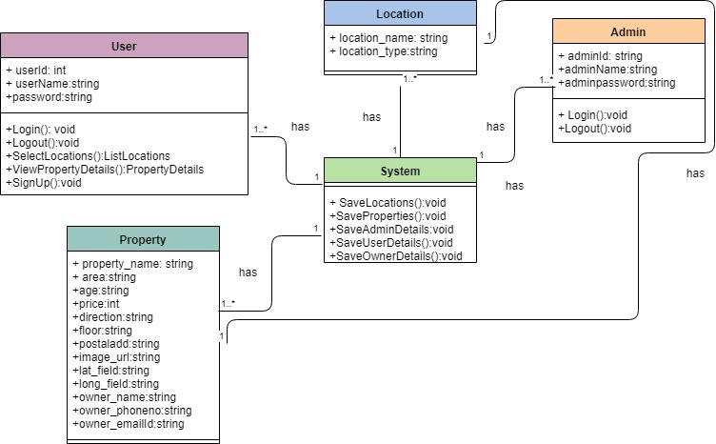

1.1.4 Component Diagram

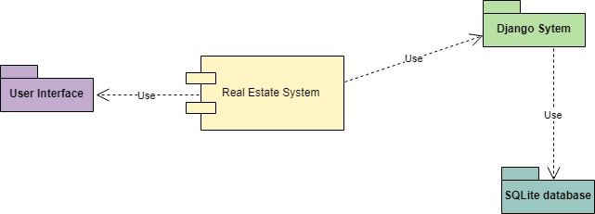

1.1.5 Deployment Diagram

